Single Mothers-
CONNOTATIONS & BIAS
WATCH & DISCUSS: https://www.youtube.com/watch?v=Nr8H8Yx1-2E
The quotes below are taken from an article about single mothers in America. Keeping in mind the importance of word connotations and the concept of bias, how do the quotes below create a richer meaning?
- Make notes in the middle column about connotations and bias. Analyze the language. Do you notice any words that are positive or negative? Any vernacular language? What about the connotations of the references?

- It used to be called illegitimacy. Now it is the new normal.
- Once largely limited to poor women and minorities, motherhood without marriage has settled deeply into middle America.
- Meanwhile, children happen.
- She described her children as largely unplanned, a byproduct of uncommitted relationships.
- I want to do things with her, but I end up falling asleep.

- Using a class spinner, we will choose a quotation number.
- Find a partner.
- Share ideas about one quote with a partner.
- Repeat.
- Compare your answers to the ones in black.
- Now read the original article in the NY Times and the response in Slate [both articles below].

For Women Under 30, Most Births Occur Outside Marriage
By JASON DePARLE and SABRINA TAVERNISEFEB. 17, 2012
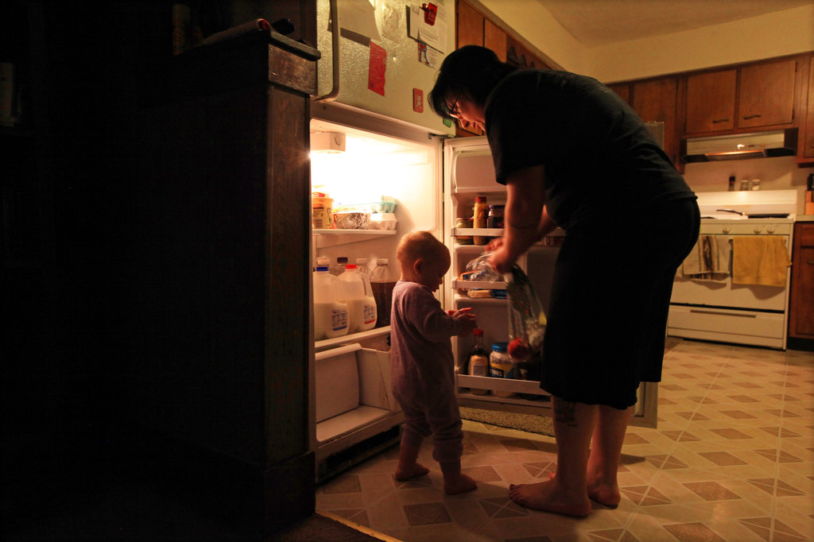
Amber Strader, of Lorain, Ohio, described her pregnancies as largely unplanned, a byproduct of relationships lacking commitment. CreditNicole Bengiveno/The New York Times

LORAIN, Ohio — It used to be called illegitimacy. Now it is the new normal. After steadily rising for five decades, the share of children born to unmarried women has crossed a threshold: more than half of births to American women under 30 occur outside marriage.
Once largely limited to poor women and minorities, motherhood without marriage has settled deeply into middle America. The fastest growth in the last two decades has occurred among white women in their 20s who have some college education but no four-year degree, according to Child Trends, a Washington research group that analyzed government data.
Among mothers of all ages, a majority — 59 percent in 2009 — are married when they have children. But the surge of births outside marriage among younger women — nearly two-thirds of children in the United States are born to mothers under 30 — is both a symbol of the transforming family and a hint of coming generational change.
One group still largely resists the trend: college graduates, who overwhelmingly marry before having children. That is turning family structure into a new class divide, with the economic and social rewards of marriage increasingly reserved for people with the most education.
“Marriage has become a luxury good,” said Frank Furstenberg, a sociologist at the University of Pennsylvania.
The shift is affecting children’s lives. Researchers have consistently found that children born outside marriage face elevated risks of falling into poverty, failing in school or suffering emotional and behavioral problems.
The forces rearranging the family are as diverse as globalization and the pill. Liberal analysts argue that shrinking paychecks have thinned the ranks of marriageable men, while conservatives often say that the sexual revolution reduced the incentive to wed and that safety net programs discourage marriage.
Here in Lorain, a blue-collar town west of Cleveland where the decline of the married two-parent family has been especially steep, dozens of interviews with young parents suggest that both sides have a point.
Over the past generation, Lorain lost most of two steel mills, a shipyard and a Ford factory, diminishing the supply of jobs that let blue-collar workers raise middle-class families. More women went to work, making marriage less of a financial necessity for them. Living together became routine, and single motherhood lost the stigma that once sent couples rushing to the altar. Women here often describe marriage as a sign of having arrived rather than a way to get there.
Meanwhile, children happen.
Amber Strader, 27, was in an on-and-off relationship with a clerk at Sears a few years ago when she found herself pregnant. A former nursing student who now tends bar, Ms. Strader said her boyfriend was so dependent that she had to buy his cigarettes. Marrying him never entered her mind. “It was like living with another kid,” she said.
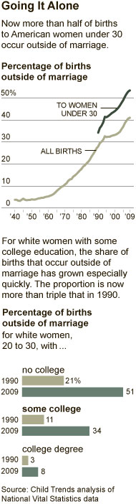
CreditThe New York Times

When a second child, with a new boyfriend, followed three years later — her birth control failed, she said — her boyfriend, a part-time house painter, was reluctant to wed.
Ms. Strader likes the idea of marriage; she keeps her parents’ wedding photo on her kitchen wall and says her boyfriend is a good father. But for now marriage is beyond her reach.
“I’d like to do it, but I just don’t see it happening right now,” she said. “Most of my friends say it’s just a piece of paper, and it doesn’t work out anyway.”
The recent rise in single motherhood has set off few alarms, unlike in past eras. When Daniel Patrick Moynihan, then a top Labor Department official and later a United States senator from New York, reported in 1965 that a quarter of black children were born outside marriage — and warned of a “tangle of pathology” — he set off a bitter debate.
By the mid-1990s, such figures looked quaint: a third of Americans were born outside marriage. Congress, largely blaming welfare, imposed tough restrictions. Now the figure is 41 percent — and 53 percent for children born to women under 30, according to Child Trends, which analyzed 2009 data from the National Center for Health Statistics.
Still, the issue received little attention until the publication last month of “Coming Apart,” a book by Charles Murray, a longtime critic of non-marital births.

Large racial differences remain:73 percent of black children are born outside marriage, compared with 53 percent of Latinos and 29 percent of whites. And educational differences are growing. About 92 percent of college-educated women are married when they give birth, compared with 62 percent of women with some post-secondary schooling and 43 percent of women with a high school diploma or less, according to Child Trends.
Almost all of the rise in nonmarital births has occurred among couples living together. While in some countries such relationships endure at rates that resemble marriages, in the United States they are more than twice as likely to dissolve than marriages. In a summary of research, Pamela Smock and Fiona Rose Greenland, both of the University of Michigan, reported that two-thirds of couples living together split up by the time their child turned 10.
In Lorain as elsewhere, explanations for marital decline start with home economics: men are worth less than they used to be. Among men with some college but no degrees, earnings have fallen 8 percent in the past 30 years, according to the Bureau of Labor Statistics, while the earnings of their female counterparts have risen by 8 percent.
“Women used to rely on men, but we don’t need to anymore,” said Teresa Fragoso, 25, a single mother in Lorain. “We support ourselves. We support our kids.”
Teresa Fragoso takes classes and works at a Lorain, Ohio, bar, where she took her son one day when she could not find a sitter.

Fifty years ago, researchers have found, as many as a third of American marriages were precipitated by a pregnancy, with couples marrying to maintain respectability. Ms. Strader’s mother was among them.
Today, neither of Ms. Strader’s pregnancies left her thinking she should marry to avoid stigma. Like other women interviewed here, she described her children as largely unplanned, a byproduct of uncommitted relationships.
Some unwed mothers cite the failures of their parents’ marriages as reasons to wait. Brittany Kidd was 13 when her father ran off with one of her mother’s friends, plunging her mother into depression and leaving the family financially unstable.
“Our family life was pretty perfect: a nice house, two cars, a dog and a cat,” she said. “That stability just got knocked out like a window; it shattered.”
Ms. Kidd, 21, said she could not imagine marrying her son’s father, even though she loves him. “I don’t want to wind up like my mom,” she said.
Others noted that if they married, their official household income would rise, which could cost them government benefits like food stamps and child care. W. Bradford Wilcox, a sociologist at the University of Virginia, said other government policies, like no-fault divorce, signaled that “marriage is not as fundamental to society” as it once was.
Even as many Americans withdraw from marriage, researchers say, they expect more from it: emotional fulfillment as opposed merely to practical support. “Family life is no longer about playing the social role of father or husband or wife, it’s more about individual satisfaction and self-development,” said Andrew Cherlin, a sociologist at Johns Hopkins University.
Money helps explain why well-educated Americans still marry at high rates: they can offer each other more financial support, and hire others to do chores that prompt conflict. But some researchers argue that educated men have also been quicker than their blue-collar peers to give women equal authority. “They are more willing to play the partner role,” said Sara McLanahan, a Princeton sociologist.
Reviewing the academic literature, Susan L. Brown of Bowling Green State University recently found that children born to married couples, on average, “experience better education, social, cognitive and behavioral outcomes.”
Lisa Mercado, an unmarried mother in Lorain, would not be surprised by that. Between nursing classes and an all-night job at a gas station, she rarely sees her 6-year-old daughter, who is left with a rotating cast of relatives. The girl’s father has other children and rarely lends a hand.
“I want to do things with her, but I end up falling asleep,” Ms. Mercado said.

More Single Moms. So What.

The New York Times condescends to single moms.
By KATIE ROIPHE
FEB 20, 20122:15 PM
The majority of children born to women younger than 30 are born to single mothers. John Moore/Getty Images.
The New York Times may as well have headlined its most emailed piece this weekend: Single Mothers Take Over the World. The point of the piece, with its peculiar moral undertone, was that the majority of babies born to women under 30 in this country are now born to single mothers, and in Lorain, Ohio, that number has climbed as high as 63 percent.
Conservatives will no doubt be elaborately hysterical over the breakdown of morals among the women of Lorain, but they will be missing the major point, which is that however one feels about it, the facts of American family life no longer match its prevailing fantasies. For those who have associated single motherhood with the poor and uneducated, and increasingly, with the urban very-educated (see the New York Times piece, the same day, on Casey Greenfield) they now have to confront the changing demographics of the vast American middle. No matter how one sees this development, and as a single mother myself I have my own views, one has to recognize that marriage is very rapidly becoming only one way to raise children. (And other countries are obviously way ahead of the United States in incorporating a rational recognition of the vicissitudes of love, and the varieties of family life, into cultural attitudes toward unmarried parents.)
One of the ways condescension makes its way into a neutral seeming New York Times story is the note the reporter chooses to end the piece on. Both of the two pieces on the single mothers of Lorain, Ohio, this weekend end with implicit judgments, with anecdotes that telegraph the unhealthiness of this new state of affairs, or whisper to the reader: “How do these women think they can get away with it?”
One ends with a freighted quote from a single mother saying she would like to do more with her daughter. (Actually it claims she would agree with a professor from Bowling Green State University’s vague conclusion that children born to married parents “experience better education, social, cognitive and behavioral outcomes”) Apparently she would agree with this professor because she would like to do more with her 6-year-old, but she often falls asleep after working full time and taking nursing classes. As if that feeling of wishing you could spend more or better time with your child is unknown to the married working mother, who of course never feels that she is too tired or distracted to do something she wanted to do with her 6-year-old, and anyway has a roast chicken in the oven, and a homemade pie cooling on the windowsill.
The Times reporters’ analysis of the economics and sociology of Lorain is punctuated by a pat “meanwhile, children happen” that is perhaps not quite as respectful as it could be of the fact that these independent-minded, apparently hard-working women are making decisions and forging families, after thinking clearly about their situation. One of the mothers quoted in the pieces says that to her and her friends “marriage is just a piece of paper.” Meaning of course that it does not ensure eternal love, or even eternal security, acknowledging, perhaps, that the father in the home is not necessarily more happily or fruitfully involved than the father outside of the home. Others describe the economic realities of not needing a man to support children, feeling the men around are too childish, or criminal, or jobless to help much, and not feeling a stigma about having a child outside of marriage. (By the time one finishes these strangely inflected articles, they seem to be arguing that these women should feel a stigma about having children out of wedlock.)
Of course, one of the reasons children born outside of marriage suffer is the culturally ubiquitous idea that there is something wrong or abnormal about their situation. Once it becomes clear that there is, at least, nothing abnormal about their situation, i.e. when this 53 percent of babies born to women under 30 come of age in the majority, the psychological landscape, at least, will be vastly transformed.
Even people who are certain that the children of single mothers are always and forever doomed to a compromised existence, are going to have to await more information about a world in which these kids are not considered illegitimate or unconventional or outsiders, where the sheer number of them redefines and refreshes our ideas of family.
In fact, the tacit judgment of the New York Times-style liberal is in many ways more pernicious than the overt moralizing of conservatives on the downfall of family and marriage. It is easy to dismiss the Santorum faction for its cartoonishly old-fashioned view of extramarital sex, and this group is at least forthright about its view, whereas the subtle psychologizing put-down of the New York Times-style liberal, the slight hint of self-congratulation that they are not a single mother in Lorain, Ohio, bringing their son to the bar where they work, is more poisonous for its pretense of fairness and open-mindedness.
This is a new world, and there are no studies or professors from Bowling Green State University, or subtly condescending New York Timesreporting, that can tell us what it will be like for these children to live in it.

